**When fear turns into love:**

**A partial explanation of political trust in China**

Yu Liu, Yu-Sung Su, Meng Zhu

**Introduction**

A plethora of surveys have persistently demonstrated an incredibly elevated degree of political trust towards central political institutions in China, as well as the nation itself (ABS, 2002, 2008, 2011, 2014, 2019; CSS 2006, 2017, 2019, 2021; CGSS, 2010). While the legitimacy of these findings remains uncontested among scholars, the interpretation of the results has given rise to an animated discourse. A key issue in this discussion revolves around the extent to which respondents' political apprehensions have impacted these figures. While some scholars maintain that trepidation has significantly inflated political trust in China, others reject its significance altogether. However, both factions operate under the same assumption: that political trust expressed by respondents cannot be genuine when it is intertwined with fear. In other words, fear and trust are mutually exclusive concepts.

Contrary to this popular notion, our paper argues that in political reality, individuals can authentically love what they fear and fear what they love. Historical accounts and memoirs from the revolutionary era reveal that many, if not most, people living under Mao's regime in China feared the Communist Party of China and Mao himself while genuinely loving them. Similar sentiments were shared by Soviet citizens under Stalin's leadership and, to a lesser degree, by those under the rule of Putin and Kim Jong-un today. Authoritarianism and totalitarianism not only trigger fear, but also often instill love under particular circumstances. Therefore, in this paper, we posit that fear not only coexists with authentic political trust in contemporary China, but it has also significantly contributed to such trust.

To bolster our claim, we invoke cognitive dissonance theory from the field of social psychology. Originated by Festinger in 1957, cognitive dissonance theory has been substantiated by numerous studies indicating that beliefs not only determine behaviors, but induced behaviors can also shape beliefs. Individuals frequently assimilate their actions that are influenced by rewards or punishments to mitigate cognitive dissonance. Surprisingly, the extensive debates on political trust in China have failed to capitalize on this well-established theory from social psychology, which, in our view, could offer valuable insights into the "fear-trust" predicament.

Our argument asserts that despite the implementation of a market economy and relaxation of social control, the Chinese state remains incredibly sturdy and has even become more influential in the recent decade since Xi took the reins of power. Its ability to dispense significant rewards and punishments effectively prompts behavioral conformity, which, in turn, increases the psychological pressure to internalize behaviors through self-persuasion. This is how fear (of missing rewards or facing punishments) becomes a driving force behind political trust.

We examine the fear-trust dynamics in present-day China through a series of public opinion surveys centered on a significant political event: the anti-corruption campaign initiated after Xi's rise to power. We consider the campaign as a "natural experiment" to observe how the growing threat of punishment among the "regime insiders" affects their level of political trust, and analyze whether the trust dynamics among them differ from those among the "regime outsiders," who are presumably much less threatened by the campaign. To identify possible disparities, we utilize a Difference-in-Differences model, with the anti-corruption campaign as the policy shock (the treatment), using CCP membership and state-sector employment to identify "regime insiders" (the treated group), and examine whether increasing fear raises political trust among the treated group. To ensure maximum comparability between the treated and control groups, we use the Propensity Scores Matching method to address concerns about non-randomness in the treatment group.

The findings lend credence to our hypothesis that "more fear leads to more trust." We do not argue that political fear invariably translates into regime support, or that regime support stems exclusively from political fear in contemporary China or anywhere else. As posited by many cognitive dissonance scholars, dissonance caused by cognition-behavior conflict would not trigger a self-persuasion process without certain conditions, two of which are particularly critical. First is the relatively low cost of changing one's opinion compared to that of altering behavior. Second is a level of (perceived) free choice: individuals will not begin internalizing an action unless they have some degree of voluntary participation in it. In section two, we will expound on these conditions and why they are present in contemporary China.

A natural challenge arises: the regime insiders may be more inclined to fake responses due to their greater level of fear. We test this "faking hypothesis" using two widely used cross-examination methods. Firstly, we compare the non-response rate of the treated group to that of the control group, checking whether the former has risen more quickly than the latter after treatment. Secondly, we compare the treated group's non-response rate on sensitive questions to that on less sensitive questions, checking whether the two develop in parallel. None of the tests indicate that the regime insiders have "faked" more during the post-treatment period. In other words, fear has likely led to genuinely increased political trust through the stronger dynamics of self-persuasion.

The rest of the paper is organized into five sections. The first section provides a brief literature review. In the second section, we expound on our theory. The third section explains our research design and hypothesis, and subsequently lays out our variables, data, and analytical models. The fourth section reports the regression results and addresses alternative explanations. We then conclude with brief remarks in the last section.

**Literature Review**

The suspicion of a potential political sensitivity bias in opinion surveys from China has been present since the emergence of large-scale political surveys in the country. Shi, who was a trailblazer in survey-based political culture studies in China, was one of the first scholars to raise this issue. To explore whether fear was the reason behind the exceptionally high levels of political trust in China, Shi conducted various tests. These included comparing the nonresponse rates between respondents with different levels of education and political interest. Ultimately, his findings did not support the "fear hypothesis" (Shi, 2008, "East Asians").

Subsequently, the proposition put forth by Shi has been buttressed by numerous studies utilizing a range of approaches. Lei and Lu (2017, Wariness), for instance, conducted two experimental surveys that revealed no discernible difference in the nonresponse rate or the prevalence of "politically correct" responses between respondents assigned to "officially affiliated surveys" and those assigned to "normal" surveys when asked questions related to political trust. Surprisingly, those participating in the "officially affiliated surveys" even exhibited a greater proclivity for critical responses, which casts doubt on the notion that political fear underpins high levels of political trust in China. Similarly, Stockmann, Esarey, and Zhang (2018, Afraid) conducted an experimental study in Beijing, which suggested that participants demonstrated more positive attitudes towards TV commercials briefly featuring the name of a central party institution, providing evidence of "affect transfer" and thus countering the "fear" explanation of political trust.

Han and Truex (2020, Word Association Test) employed an innovative method, namely Word Association Tests, to explore political attitudes in China. Their findings indicated that mainland respondents predominantly associated the Chinese Communist Party (CCP) with words having positive connotations, indicating that the high approval rate of the regime recorded in surveys reflects the genuine sentiments of respondents rather than preference falsification.

However, this line of reasoning has also faced counter-arguments. For example, by comparing Shanghai residents' support for the regime before and after a significant local purge, Jiang and Yang (2016, Lying) demonstrated a marked "purge effect," whereby respondents expressed more explicit support for the regime after the purge, while actual endorsement declined. They interpreted this divergence as evidence of preference falsification due to political fear.

Some have suggested that a mild form of "trust inflation" may be driven by fear. Tang (2016) conducted a list experiment to identify the extent of political sensitivity bias in expressed political trust in China, finding a modest level of bias. However, Munro (2018, Refusal) argues that after correcting for "refusal bias" based on refusers' response propensity, political trust in central institutions in China drops by up to 5 percent, with sensitivity bias potentially explaining the overestimation. Ratigan and Rabin (2020, Nonresponse) reached a similar conclusion but found a larger effect, with nonresponse tending to come from marginalized groups who hold a more skeptical view of government leaders. Shen and Truex (2021, Self-censorship) have demonstrated that self-censorship, as measured by item nonresponse rate on politically sensitive questions versus nonsensitive questions, is not prevalent in most competitive authoritarian states but is quite common in non-competitive authoritarian regimes such as China, particularly among marginalized groups.

Li (2022, Decoding) takes an interpretive perspective, arguing that observed trust in the central government in China is significantly inflated because it reflects people's trust in the Center's commitment to good governance, not necessarily its capacity in monitoring and disciplining local officials. When taking this "discount" into consideration, that is, by measuring the gap between trust in commitment and trust in capacity, the actual level of political trust in the Center is much lower.

These different, often conflicting, findings on the issue are puzzling. However, we argue that political fear and trust are not necessarily contradictory. Both sides can be partially correct but in different ways: the sincerity detected by one side and the fear detected by the other side are not mutually exclusive. In fact, they could be mutually reinforcing under certain conditions. We explore this argument further in the rest of the paper, aiming to shed more light on this complex issue.

**Theory**

Our theoretical framework is constructed on the cognitive dissonance theory from social psychology. This theory, initially introduced by Festinger in 1957, asserts that when individuals encounter contradictory cognitions, the resulting dissonance stimulates a desire to restore cognitive consistency. To achieve such consistency, individuals may either modify their behaviors to align with their existing beliefs or change their beliefs if modifying their behaviors proves too arduous or expensive. For instance, a smoker may experience cognitive dissonance upon acknowledging that smoking is harmful to their health. To alleviate this dissonance, they might either quit smoking or, when it is too challenging, adopt the belief that "smoking is not as bad as it seems" or "the benefits of smoking outweigh the drawbacks for me." Various methods of resolving cognitive dissonance imply that beliefs can influence behaviors, and conversely, behaviors can impact beliefs. The latter is particularly intriguing and provocative, inspiring a plethora of studies over the years. Despite many revisions, this fundamental framework endures, gathering new evidence from animal experiments and neuroscience (Lydall et al., 2010; Van Veen/Krug, 2009, see bibliography at the end of the text).

The cognitive dissonance theory has spawned numerous research paradigms, including the well-known "induced compliance paradigm." This paradigm was first tested in an experiment by Festinger and Carlsmith (1959), in which college students were offered a monetary incentive to lie about a boring task, leading to attitude change as a means of reducing cognitive dissonance.[1] Subsequent studies have replicated these findings, suggesting that behavior induced by rewards or punishments can indeed lead to genuine attitude change as individuals internalize these behaviors to reduce dissonance. Some scholars have argued that attitude change is aimed at restoring self-image or self-affirmation (Steele, “the psychology of self-affirmation,” 1988) rather than just cognitive consistency, which we find to be a reasonable complement to the earlier version of the theory, rather than a refutation.[2]

Although not all behaviors have the power to cause changes in attitudes, dissonance theorists underscore the significance of free choice in inducing self-persuasion (Brehm & Cohen, 1962; Linder, Cooper, & Jones, 1967; Cooper & Fazio, 1984; Joule, 1998). Apart from the relative costs of complying versus resisting behaviors, the level of personal responsibility plays a pivotal role in triggering attitude change. People are less inclined to justify and internalize coerced behaviors, whereas the self-persuasion process commences only when individuals feel accountable for their actions to some extent. For example, the Jews in the concentration camps could not persuade themselves to embrace Nazism because of their forced presence, whereas the Nazi guards in the camps would likely reinforce their allegiance to Nazism owing to their voluntary choice to be there.

Another research paradigm, the effort justification paradigm, explores the impact of behavior on attitudes by highlighting the powerful effects of earlier and smaller efforts. One experiment found that a group that exerted more effort to gain membership in a club developed a stronger affinity for the club compared to the control group (Aronson & Mills, 1959). This outcome was consistently replicated in diverse settings (Freedman & Fraser, 1966; Staw, 1981; Axsom & Cooper, 1985). The Chinese proverb, "It is hard to get off the tiger when you are already on its back," exemplifies the "foot-in-the-door" effect. The effort justification paradigm extends the induced compliance paradigm, with the former elucidating the initiation of self-persuasion and the latter the amplification of it.

The relevance of these cognitive theories for the study of political trust in contemporary China is significant. To summarize the cognitive theories discussed above, two conditions are critical in initiating the self-persuasion process. Firstly, the presence of an incentive structure that tilts in favor of compliance or against defiance leads to compliance. Secondly, the exercise of free choice by individuals in adopting compliant behaviors drives attitude change to restore cognitive consistency or self-image. Both conditions, in our view, are firmly entrenched in contemporary China.

Firstly, the present-day Chinese regime exhibits a tilted incentive structure, imposing severe penalties for noncompliance. The very nature of authoritarianism entails the state's exceptional capacity to mete out rewards and punishments. However, the degree of authoritarianism varies, thereby impacting the extent of the "gradient" of the incentive structure. In retrospect, it is evident that totalitarianism often garners more devotion than "regular" authoritarianism. In a "regular" authoritarian regime, the state's control over power and resources is limited, resulting in a constrained level of political conformity, which in turn generates limited value change. In contrast, under totalitarianism, the state is the sole purveyor of significant rewards and penalties, and political activism is linked to success across almost all spheres. Consequently, individuals who expend greater efforts in "practicing" political loyalty are more likely to internalize it.

Contemporary China no longer resembles the Maoist totalitarian state. The planned economy has been replaced by the market economy, and most individuals can lead a relatively non-politicized life. Consequently, the political zeal characteristic of the Maoist era has largely waned. However, the party-state still wields an iron grip on power and resources. Although the degree of control is relatively lower than in the past, it remains significantly higher than in most other nations. The state's authority extends beyond the vast state sector to include a "hanging sword" over the market economy and civil society.[3] The demarcation between the state, society, and market is capriciously indistinct, and property rights are protected only to the extent that they do not jeopardize state policies or regime security. For instance, in 2021, the government's policy shift to prohibit the entire after-school tutoring industry instantly wiped out millions of jobs and precipitated a dramatic decline in the stock prices of numerous private companies, without eliciting any collective opposition. Given the party-state's dominant power, it is reasonable to expect individuals to find political compliance far less costly than noncompliance.

The already tilted incentive structure in China has become even more lopsided since Xi's ascension to power. There is little doubt that the party-state has intensified its grip on the economy and society since the mid-2010s. In terms of the economy, a "state sector advancing and private sector retreating" trend has emerged. Despite exhibiting only one-third of the productivity of private companies, state investment has grown at a much faster pace than private investment since 2012, with the former registering a growth rate of 10 percent in 2022, while the latter only at 0.9 percent.[4] On the social front, the "grid management" system has been equipped with high-tech surveillance capabilities, such as facial recognition and phone trackers, which have "given wings to the tiger," to borrow a Chinese proverb. One indication of the remarkable capacity for social monitoring is the implementation of zero-COVID policies for three years. From 2020 to 2022, the state was able to track the whereabouts of billions of people and effectively restrict the movement of any suspected COVID cases. In the CCP's own words, the centralization of power has reached such a level that "whether it's the party, government, military, academia, or society, whether it's the East, South, West, North, or Middle, the CCP leads it all."[5]

There does exist a degree of volition regarding political compliance in contemporary China. Despite strict prohibition of open political opposition, the level of political activism is subjective and dependent upon individual choice. In this sense, freedom of choice does exist in today's China (as well as in Mao's China). Undeniably, authoritarianism inherently imposes limitations upon free choice. However, despite the lack of freedom to publicly oppose the regime and the limited freedom to criticize its policies, individuals possess the freedom to choose their level of participation. For instance, in modern China, individuals can opt to join or not join the CCP, and they can decide to work in the state sector or not. Within the regime, individuals can determine their level of engagement in activities that promote self-advancement or recognition. Outside the regime, individuals such as directors, social media bloggers, or businessmen can choose whether or not to create a "patriotic movie," incite nationalism, or apply for government subsidies. Those who participate more actively are likely to develop a stronger inclination toward self-persuasion in accordance with cognitive dissonance theory. [6]

Voluntary participation in the regime is widespread throughout China. One telling statistic is that, as of the close of 2020, the CCP boasted a membership of 95 million, with almost 20 million enlisting since 2012. [7] Although some individuals may join the CCP due to ideological convictions, many - if not the majority - are enticed by the incentives and sanctions that the CCP can bestow. The immense size of the state sector also underscores the extent of voluntary participation. According to a study by Ang (2018) titled "Autocracy with Chinese Characteristics," the Party and state apparatus alone employ more than 50 million individuals." [8]

Political participation has intensified over the past decade as a response to growing uncertainties faced by the private sector. The state sector has become increasingly popular among job seekers, and the number of applicants for national civil service has risen from 1.4 million in 2015 to 2.5 million in 2023. The proportion of college-educated CCP members has also increased from 40 percent in 2012 to 53.2 percent in 2022, indicating that the CCP has become more selective. [9] As a small yet symbolic indication of active political compliance, Chinese bureaucrats have begun to emulate Xi's dress code since the late 2010s, making his distinctive jacket style fashionable among civil servants.[10] Once again, no one is coercively imposing the "Xi jacket" on anyone; it is entirely voluntary on the part of bureaucrats. The existence and intensification of widespread regime participation fulfill the second condition for self-persuasion.

Taking all of this into account, it appears reasonable to apply the cognitive dissonance theory to analyze the dynamics of regime support in modern-day China. Our argument is that the remarkably strong state in China has effectively induced, though not coerced, widespread political compliance through an increasingly skewed incentive structure, and regime participation (specifically, the voluntary aspect of it) triggers a process of self-persuasion to align beliefs with induced behaviors. This is how "fear" can be transformed into "love" in contemporary China. We do not assert that this mechanism accounts for the entirety of regime support in China, but it does provide a substantial explanation for the fear-trust paradox

**Research design, variables and data**

We utilize the anti-corruption campaign initiated subsequent to Xi's ascendance to power as a "natural experiment" to assess our hypothesis that apprehension can instigate an upsurge in political reliance. It is well-known that Xi's widespread anti-corruption campaign has been the "longest, widest-ranging and most penetrative anti-corruption campaign in the post Mao-era," which is a significant indication of the campaign's scope. From 2012 to 2022, the authorities investigated more than 4.6 million cases, with virtually all of them resulting in punishments of varying degrees. Notably, the campaign scrutinized 207,000 "local heads" (yibashou), and no level of cadres remained immune to the campaign. As per the Party's terminology, "Both tigers and flies should be cracked down on." The highest governing body of the CCP, the members and alternate members of the 18th and 19th Central Committee, were also among the investigated. 61 members (about 8.4 percent) were removed. The Central Commission for Discipline and Inspection (CCDI), which towers above the judicial system, also contributed to the rigor of the campaign. The campaign has shown no indication of subsiding. As depicted in Figure 1, in 2020, 618,000 investigations were conducted, followed by 631,000 in 2021 and 592,000 in 2022, with the numbers remaining near their peak.

We take the anti-corruption campaign, launched after Xi's rise to power, as a "natural experiment" to test our theory that fear can lead to increased political trust. As widely known, Xi launched an extensive anti-corruption campaign after assuming power, which has become the "longest, widest-ranging and most penetrative anti-corruption campaign in the post Mao-era.”[11] The scale of the campaign is remarkable: from 2012 to 2022, more than 4.6 million cases were investigated, with nearly all cases resulting in punishments of varying degrees.[12] Among the investigated, 207,000 involved "local heads" (*yibashou*). No level of cadres has been exempt from the campaign. "Both tigers and flies should be cracked down on," as stated in the Party language. Among the members and alternate members of the 18th and 19th Central Committee, the highest governing body of the CCP, 61 members (about 8.4 percent) were taken down.[13] With the Central Commission for Discipline and Inspection (CCDI) standing above the judicial system, the severity of the treatment is also well documented.[14] The campaign shows no signs of dwindling either. As shown in Figure 1, in 2020 there were 618,000 investigations, followed by 631,000 in 2021, and 592,000 in 2022, with the numbers remaining close to their peak.

It is imperative to avoid presuming that the anti-corruption campaign is solely directed towards eradicating corruption. It encompasses a range of tasks, including neutralizing potential adversaries, eradicating factionalism, suppressing disloyalty to the prevailing ideology, and punishing slack policy implementation. As noted by Carothers, the anti-corruption campaign has transformed into an "omnipotent tool" that is increasingly employed to ensure solidarity and efficacy across political and policy realms (Carothers, all-purpose, 2021). Moreover, scholars have pointed out that the campaign's implementation is contingent on factional loyalty (Shih, “Protective Umbrella,” 2018; Pei, 2018). The campaign's sweeping and arbitrary nature is precisely what causes potential targets to feel apprehensive.

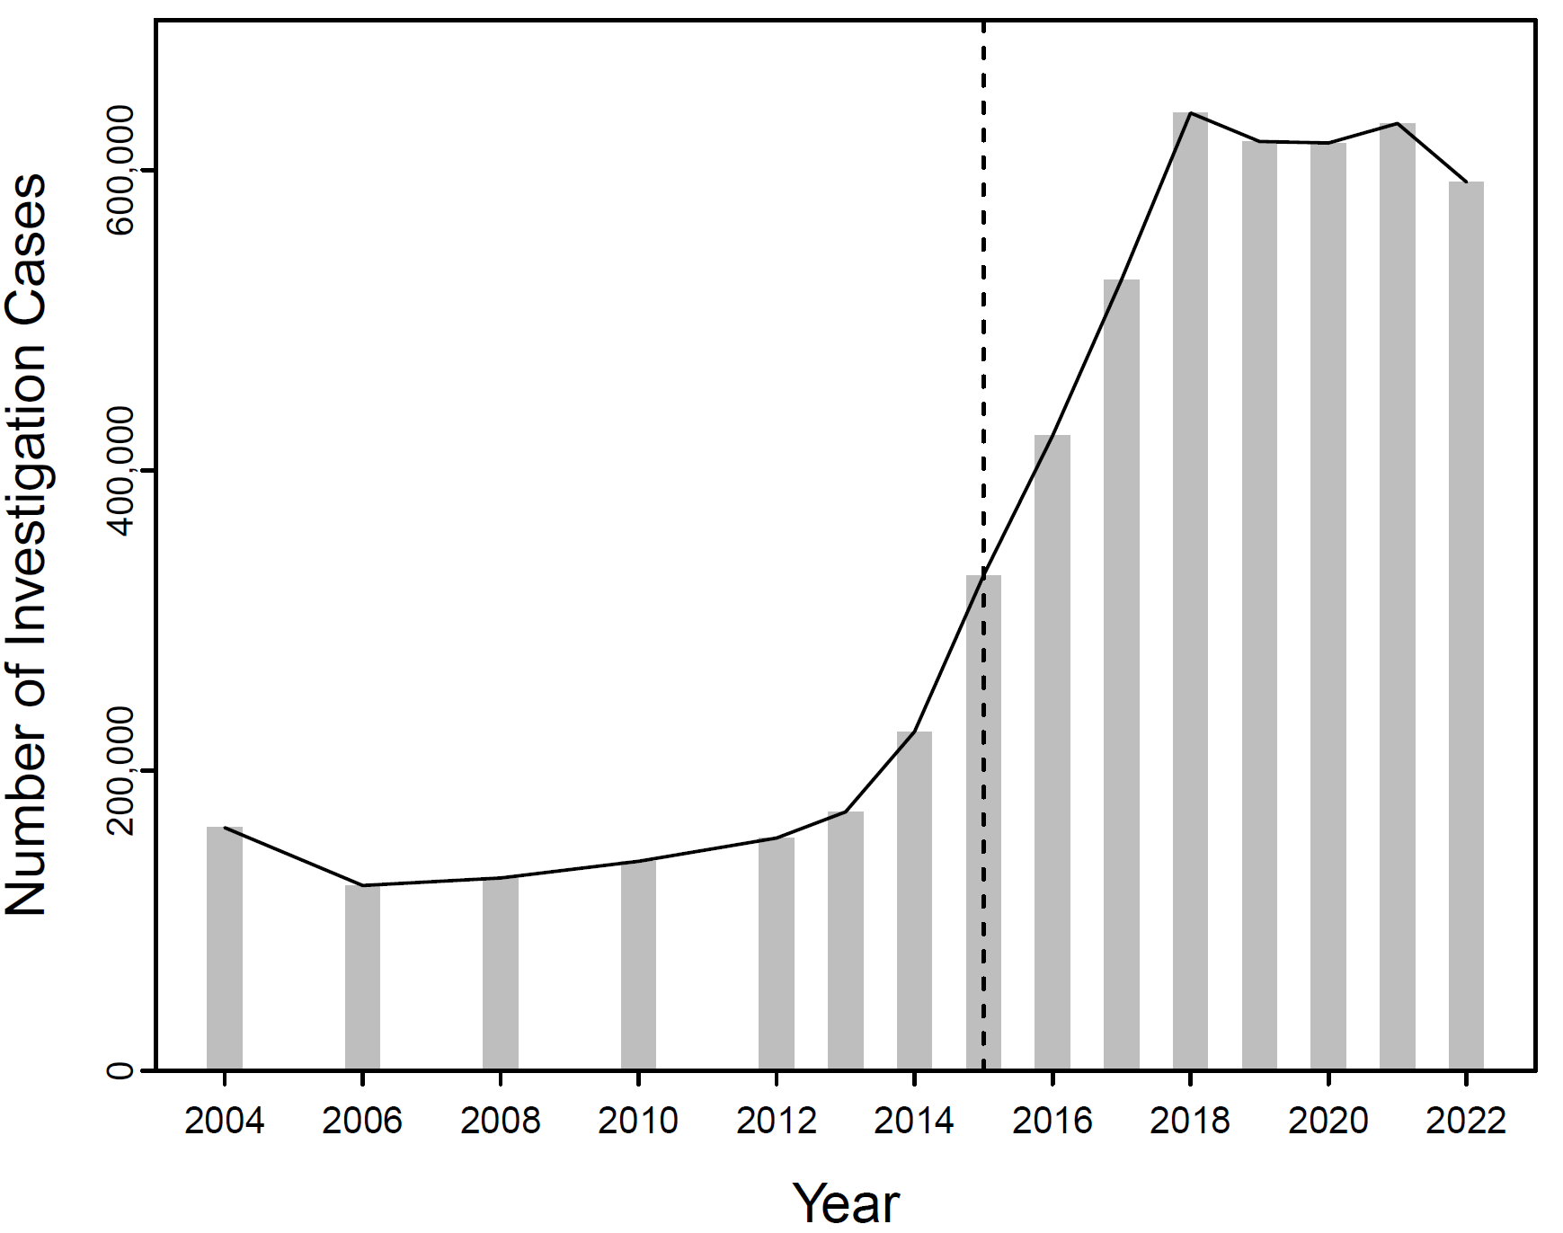

**Figure 1: Trend of Corruption Investigation Cases in China (2004-2022)**

Source: Annual work reports of the Central Commission of Discipline Inspection of the CCP (2004-2022).[15]

It is plausible to presume that the anti-corruption campaign has induced greater apprehension among "regime insiders" than "regime outsiders," given that the campaign mainly targets insiders. This anxiety has possibly resulted in more significant endeavors towards political conformity: insiders are not only required to be more financially self-restrained (the primary focus of the anti-corruption campaign) but also must adhere more closely to the party's ideology and demonstrate greater diligence and proactivity in their daily duties to secure their safety amid this whimsical storm. Essentially, the level of compliance has considerably intensified. Notably, these intensified efforts are not necessarily rewarded with greater incentives but are often aimed at reducing the risk of punitive measures.[16]

Building on our theoretical framework, which posits that heightened political awareness leads to greater political dependence, we suggest that, under the conditions outlined above, political trust among regime insiders who opt to remain within the regime will undergo a more significant surge compared to regime outsiders after the initiation of the anti-corruption campaign, which poses a severe risk to individuals within the regime, thereby promoting greater adherence. To evaluate this proposition, we employ a Difference in Differences model, where the anti-corruption campaign functions as the treatment period and the regime insiders form the treated group, to ascertain whether such a variation has emerged.

It is noteworthy that we do not consider 2012, the year when Xi ascended to power, as the treatment year since it required time for the campaign to attain its full intensity and for the targeted individuals to appreciate its severity. While analogous campaigns had taken place under prior leadership, they had led to only a negligible number of convictions. [17] As Figure 1 demonstrates, the extent of the campaign did not reach a particularly "unusual" level until roughly 2013. Therefore, we opt to utilize 2013 as the dividing point.

We would prefer to rely on a single set of surveys for our analysis, such as the China Barometer Survey (CBS) or the Chinese Social Survey (CSS). Unfortunately, none of these surveys measure both our treatment variable and outcome variable in a manner that covers the entire period of interest. For instance, while the political trust question is present in all five waves of the ABS, the "nature of job" question is missing in waves 2 (2008) and 3 (2011), making it difficult to identify "regime insiders" for those rounds. On the other hand, while the CSS surveys have the "nature of job" question, only a few of the surveys feature the political trust question, making it challenging to observe pre-treatment trends. Similarly, the Chinese General Social Survey (CGSS) only has the political trust question in one round (2010). As a result, we have to use a combination of surveys, including CBS2002, CBS2008, CBS2014, CBS2019, CGSS2010, CSS2006, CCS2017, CSS2019, and CSS2021, to conduct our analysis. However, the treatment and outcome variable question wordings in the three surveys are quite similar (refer to Appendix B for details), justifying our approach of survey combination.

The outcome variable in our research is trust in the central government, which is measured using a survey question that asks respondents to rate their level of trust in various institutions, including the central government, on a Likert scale. However, we note that different surveys have employed varying scaling methods, some of which utilize a 4-point scale while others use a 6-point scale. These scales range from "completely trust" to "completely distrust." To ensure comparability across surveys and minimize the possibility of measurement errors, we have assigned a code of 1 to respondents who explicitly express trust in the central government, regardless of the scale used, and 0 otherwise. Additionally, if a middle category is present, meaning respondents express neither trust nor distrust, they are also coded as 0.

Figure 2 depicts the distribution of political trust among Chinese citizens in the central government across multiple surveys utilized in this study (the left panel) and by years (the right panel). Due to factors such as fear or love (or their intermingling, as argued in this paper), respondents tend to be hesitant in expressing distrust toward the central government. Instead, changes in the level of trust are more subtly reflected in the proportion of respondents selecting the highest category of the trust scale ("completely trust"). Furthermore, the limited number of respondents selecting distrustful responses leads to an imbalance in the number of cases when using a binary categorization of trust and distrust.[18] To address this issue, we construct an additional outcome variable that represents a dummy between the "completely trust" category and all other categories. This will serve as a robust check on the reliability of the outcome variable in our analysis

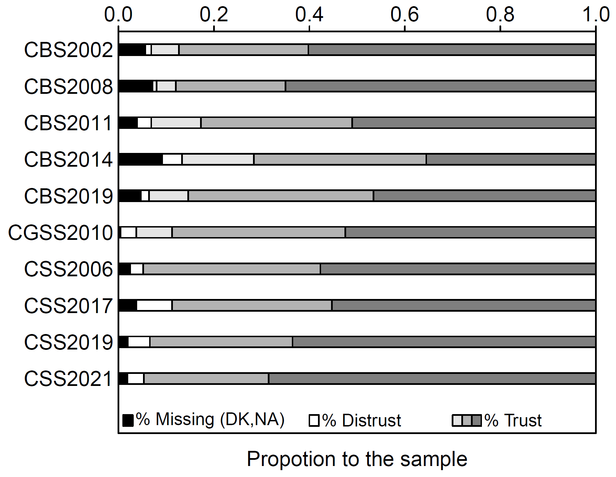 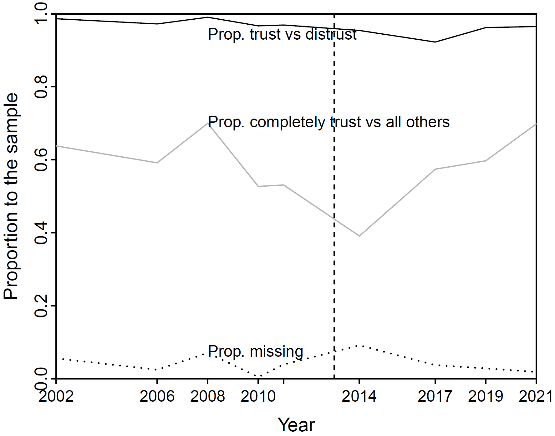

Figure 2: Distribution of political trust of Chinese people in the central government across multiple surveys and by years. The left panel displays the distribution of political trust toward the central government in China. The different shades of gray bars correspond to respondents who expressed varying levels of trust, ranging from somewhat trust (light gray) to completely trust (dark gray), while the white bars represent respondents who expressed distrust, regardless of the degree. The black bars indicate missing data from respondents who refused to answer or responded with “don't know” or “not sure”. The right panel depicts the trends of the proportion of trust (trust vs. distrust), proportion of completely trust (completely trust only), and the missing category over time between 2002 and 2021 using solid, gray, and dotted lines, respectively. As evidenced by numerous surveys, the majority of Chinese citizens exhibit trust in the central government. Notably, the trend of proportion of completely trust displays greater variation than that of proportion of trust. Moreover, there is no discernible upward or downward trend in the non-response rate.

In our main models, we utilize CCP membership and state-sector employment to discern "regime insiders," i.e., the treated group. To be more precise, respondents who are both CCP members and employed in the state sector are assigned to the treated group. CCP membership is a straightforward binary variable and requires minimal clarification. In contrast, categorizing jobs as either state or non-state sector is accomplished by amalgamating responses to a specific question across surveys: "What is the nature of your current (or pre-retirement) work unit?" [19] Responses commonly comprise around ten categories, ranging from "the CCP and government organs" to "self-employed individuals" (see online Appendix A). [20] We designate all CCP and government organs, state-owned/state-controlled/collective enterprises, and government-affiliated institutions (*shiye danwei*) as the state sector (coded as 1), and all other categories, as well as peasants, unemployed and retired individuals, as the non-state sector (coded as 0), illustrated in Figure 3. However, we exclude pure physical labor in the state sector, such as janitorial staff working in governmental buildings, construction laborers in a state-owned enterprise, or cooks in a public university, from the treated group.[21] Our primary objective is to ascertain how fear impacts political trust, and there is no reason to assume that the anti-corruption campaign realistically threatens such physical labor, regardless of how we construe the campaign. Additional details regarding our job coding rules are available in online Appendix A.

We utilize propensity score matching (PSM) techniques to deal with the potential issue that the treatment is not randomly assigned. Specifically, individuals who obtain state-owned employment may do so due to personal traits or a high level of trust in the state, which violates the assumption of treatment ignorability (citation here). Moreover, since the control group outnumbers the treated group, we employ 1 vs. 3 nearest neighborhood matching, in addition to 1 vs. 1 matching, to ensure the robustness of our results.

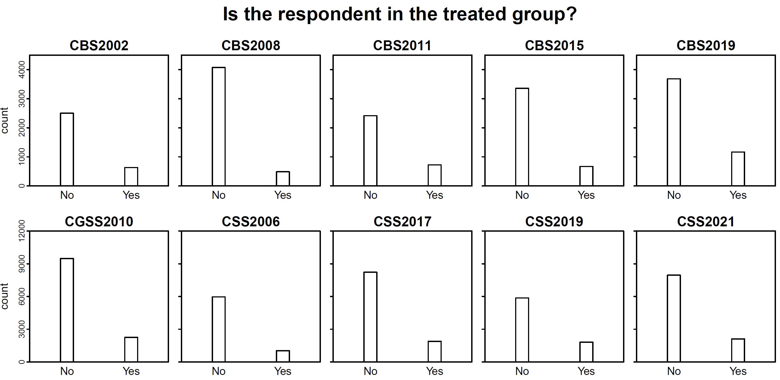

Figure 3: The treatment variable across multiple waves, which distinguishes the treated group (regime insider) from the control group (regime outsider) by nature of work units and CPP membership.

Several covariates are included as control variables in the study, namely age, gender (1: female; 0: male), education (1: elementary; 2: junior high; 3: senior high; 4: college education; 5: graduate level education), marital status (1: married; 0: otherwise), ethnicity (1: Han; 0: non-Han), and household registration status (1: rural registry; 0: non-rural registry). Summary statistics of these variables are presented in Figure 4. Expanding the range of covariates would enhance the conditional ignorability of treatment assignment, but due to the significant amount of missing data and limited availability of variables across surveys, we are constrained to utilizing only these six covariates.

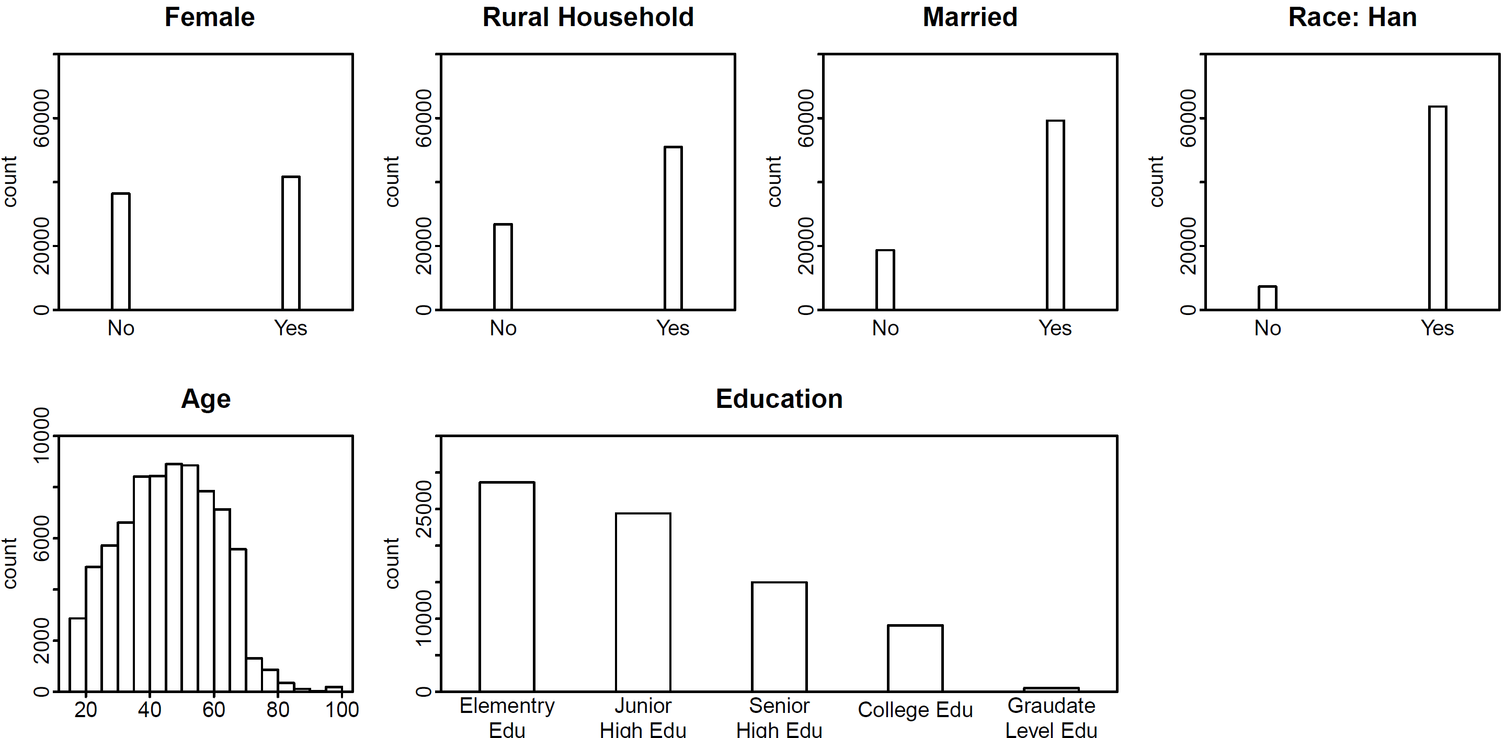

Figure 4: Summary statistics of covariates.

We employ the PSM-DID modeling approach to ascertain the impact of state dependence over time on the political trust of Chinese citizens in their central government. The formal expression of the DID regression is as follow:

Here *Y* denotes a binary outcome of political trust, while the treatment variable represents the presence of a Chinese Communist Party member who is employed in a state-sector work unit. Time serves as an indicator of exposure to the treatment post-2013. The control covariates are represented by **X**. coefficients correspond to their respective variables. The quantities of interest in this study is , the coefficient of interaction between treatment and time. Specifically, we aim to utilize measure whether the heightened fear following 2013 has led to an increased affection and subsequently, greater trust in the central government among individuals who were relatively more reliant on state support.

To validate our results, we will undertake numerous tests to evaluate the credibility and robustness of our findings. Firstly, we will conduct a robustness test by substituting the political trust outcome variable with a different indicator. Specifically, we will use a binary variable embodying "complete trust", as opposed to other responses, rather than a binary variable distinguishing trust from distrust. This alternative variable might be viewed as a more intricate measure of political trust. Our aim in this endeavor is to assess whether the treatment effect we have discerned can withstand a more stringent evaluative framework.

Secondly, we undertake two sensitivity analyses utilizing an alternative measure of political fear. Instead of depending on the "party membership plus state sector job" to discern political fear, we argue that "party membership plus higher education" constitutes a credible metric of political apprehension after the mid-2010s. The justification for this emanates from the idea that the highly educated, albeit not feeling directly menaced by anti-corruption campaigns, are increasingly susceptible to the ideological "sword showing" tactics (*liang jian*) that materialized in the mid-2010s. This is substantiated by the shuttering of numerous liberal-leaning social media accounts, the dwindling of once-flourishing investigative journalism under escalating pressure, the ubiquity of cameras in college classrooms, and the notorious repression of numerous human rights lawyers in 2015. [22] Consequently, higher education, as a proxy for ideologically precarious occupations including journalists, educators, media and social media personnel, publishers, and members of the film, music, and art industries, may serve as a reasonably robust gauge of political fear, irrespective of their affiliation with the regime.

Thirdly, we shall implement a placebo test to address the potential concern of omitted random variables that may impact the outcome. This entails reshuffling the treatment status within the dataset to produce a fake treatment variable (Cantoni 2009, Chetty2017)). Following this, we will supplant the original treatment variable with the fabricated one and regress such a variable on the outcome variables. This procedure will be executed 24,000 times to reinforce the identification power of the test. The interaction effect of fear and time shall pass the placebo test if the simulated estimates do not encompass the original one. In other words, our findings are less susceptible to being influenced by unobserved random variables.

**Statistical Results**

Figure 5 traces the evolution of political trust among regime insiders (treated group) and outsiders (control group) under two different outcome setups within both original and matched dataset conditions. This visualization allows for the detection of deviations from the parallel trend, a fundamental prerequisite for the application of the Difference in Differences (DiD) modeling strategy. Notably, trust in both groups underwent a relative decline, possibly due to the "modernization" effect whereby socioeconomic development cultivates "critical citizens" (Norris, 1999; Dalton and Welzel, 2014). The treated group, which typically has a more advanced socioeconomic status, also shows a heightened level of "criticalness."

However, the scenario post-treatment is distinct. While both groups have exhibited an increase in their level of political trust, they markedly diverge in terms of the degree of change, suggesting that the common time trend does not fully explain the observed differences. If some might attribute the higher political trust of the treated group to self-selection bias - that is, more politically trusting individuals are more likely to become "regime insiders" - the pre-treatment trends seem to counter this argument. Prior to the treatment time, the treated group indeed had, on average, lower levels of political trust, even after profile matching. Consequently, the divergence is likely propelled by specific dynamics post-treatment.

In sum, across these six panels, there is no clear breach of the parallel trend assumption. The response curves for regime insiders and outsiders coincide prior to 2013, while displaying substantial divergence post-2013. This suggests an amplified treatment effect of fear after 2013, aligning with our hypothesis.

Subsequently, we venture into investigating whether the treatment and the observed divergence share a causal connection through regression models. Our principal quantity of interest is primarily the coefficient of the interaction between the treatment time (post-2013 years) and regime insiders. This interaction is the source of the treatment effect of fear in our Difference-in-Differences design.

Before fitting the DID models, we preprocess the data using nearest neighbor matching to address potential nonrandom treatment assignment. As demonstrated in Figure 3, the treated units are outnumbered by the control units. Consequently, we employ two variant matching methods. In addition to matching one treated unit with a single control unit scenario, we also employ a method that matches one treated unit to three control units to mitigate potential bias arising from matching with only one control unit.

Next, we carry out balance checks on the covariates and the common support between the treatment and control groups to assess the quality of the matching. Figure 6 displays the absolute standardized differences in the means of covariates between the treated and control groups under two matching scenarios. The open circles and solid dots within the two panels correspond to the unmatched and matched results, respectively. The solid dots approximate more closely to the open circles in both panels, suggesting that following the matching process, the covariates between the treated and control groups are more evenly balanced than the unmatched ones. Moreover, the 1 versus 1 matching exhibits a more balanced outcome than the 1 versus 3 matching. Figure 7 provides a visual examination of the common support of the matched samples. Under both matching scenarios, it is discernible that the propensity scores of treated units, regardless of their values, have their matched counterparts in control units. This indicates the presence of common support and an overlap of the response surfaces between treated and control groups.

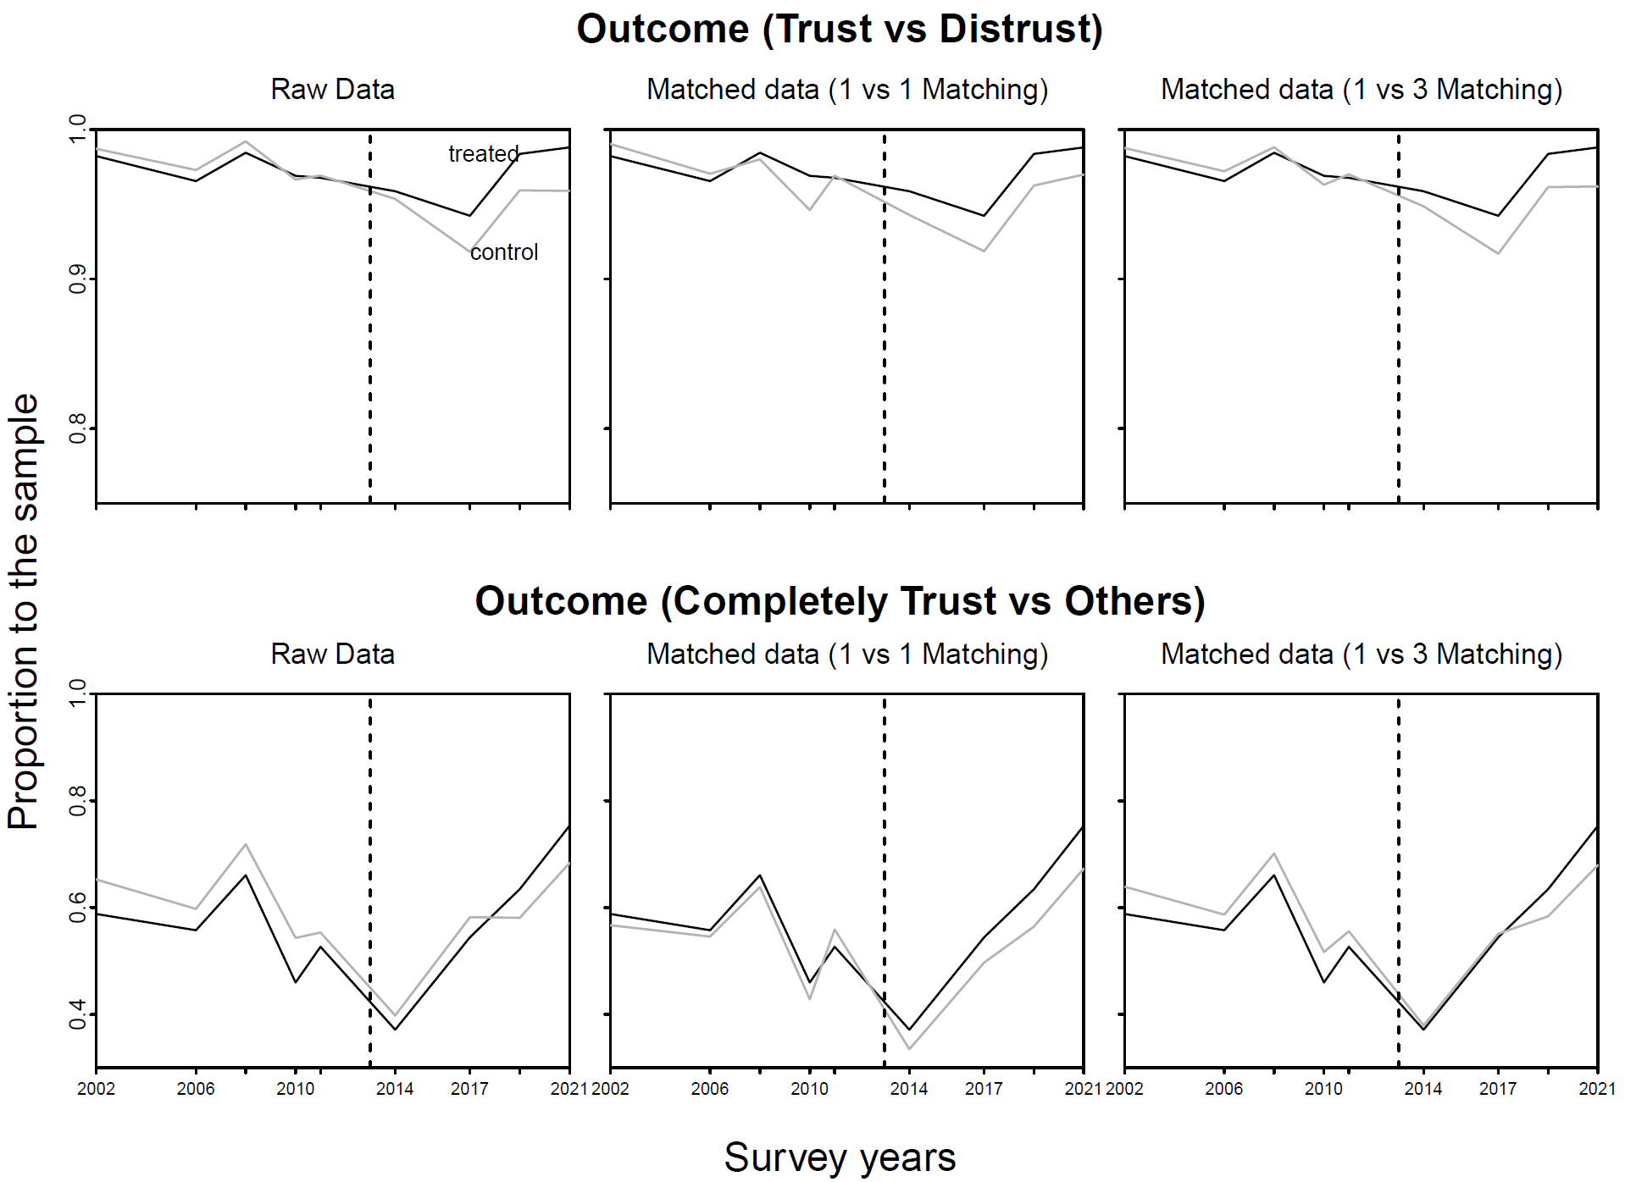

Figure 5: Trajectory of political trust among the treated and control groups. The black and gray lines depict the respective trends of political trust for the treated and control groups. Irrespective of the two outcome configurations, the treated and control lines coincide prior to 2013 and diverge post-2013, signifying the intensified treatment effect. Overall, the absence of any substantial deviation from the parallel trend assumption substantiates the aptness of employing the Difference in Differences modeling strategy.

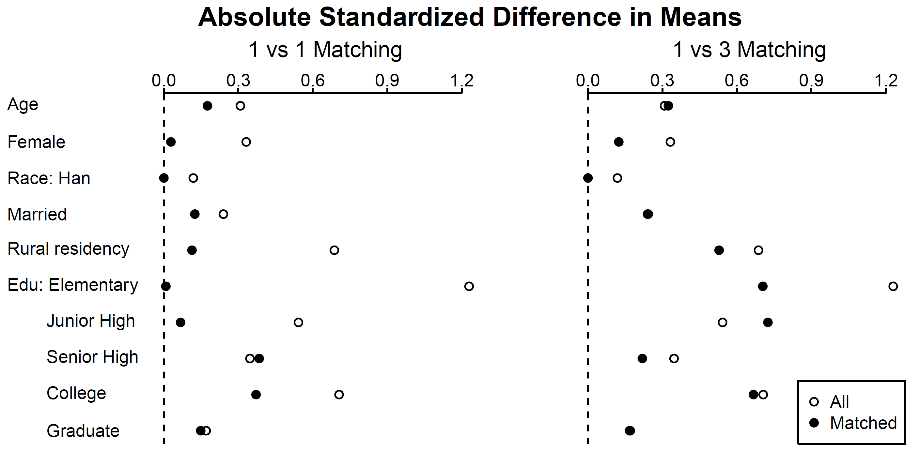

Figure 6: Plots of standardized differences in means of covariates between the treated and control groups under the raw and matched datasets. Overall, the matched outcomes exhibit smaller differences in the means of covariates, signifying that the covariates are more evenly balanced under the two matching scenarios.

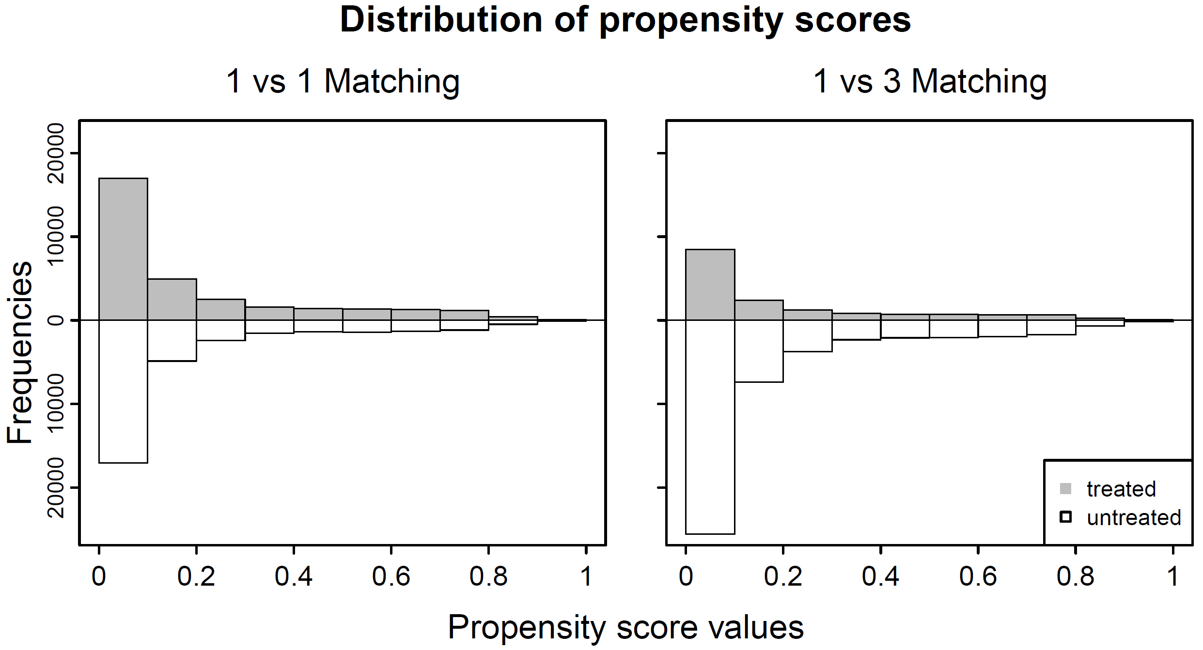

Figure 7: Display of propensity score distributions between the treated and control groups. Overlaps in each of the value bins are apparent in both panels, signifying the presence of common support.

Figure 8 illustrates the regression estimates of the DID models for unmatched and matched samples using two distinct outcome variables. The left panel of Figure 8 regresses a binary outcome distinguishing trust from distrust on the treatment, time variables, and pertinent covariates. In contrast, the right panel regresses a binary outcome separating completely trust from other categories on the same array of variables.

Figure 8 showcases the regression estimates of the Difference-in-Differences models for unmatched and matched samples using two separate outcome variables. The left panel of Figure 8 regresses a binary outcome differentiating trust from distrust on the treatment, time variables, and relevant covariates. Conversely, the right panel regresses a binary outcome that distinguishes complete trust from other categories on the same set of control variables.

The focal point is the coefficients of the interaction between treatment and time, which exert a positive and significant influence on the outcomes in both panels. These estimated effects range from 0.36 to 0.96. This translates to an average increase in the probability difference between regime insiders and outsiders expressing trust in the central government of 10% to 24% after 2013 compared to before 2013. This observation is in alignment with our hypothesis that the heightened political control after 2013 amplified fear, which subsequently fostered an affinity towards the state among those individuals who were significantly reliant on it.

Figure 8 also illustrates that the interaction between treatment and time significantly impacts the alternative measure of outcome in the right panel. The estimated effects for this measure range from 0.28 to 0.58. This suggests that, on average, the probability difference between regime insiders and outsiders expressing absolute trust in the central government widened by 7% to 14.5% post-2013 compared to pre-2013. This validates our proposition even when taking into account the variations in the measurement of the outcome, signifying that the treatment effect is still applicable for those individuals who have already expressed completely trust in the state. This robustness in our findings lends further credibility to our assertion that the intensified political control after 2013 led to an increased affinity towards the state among those significantly reliant on it.

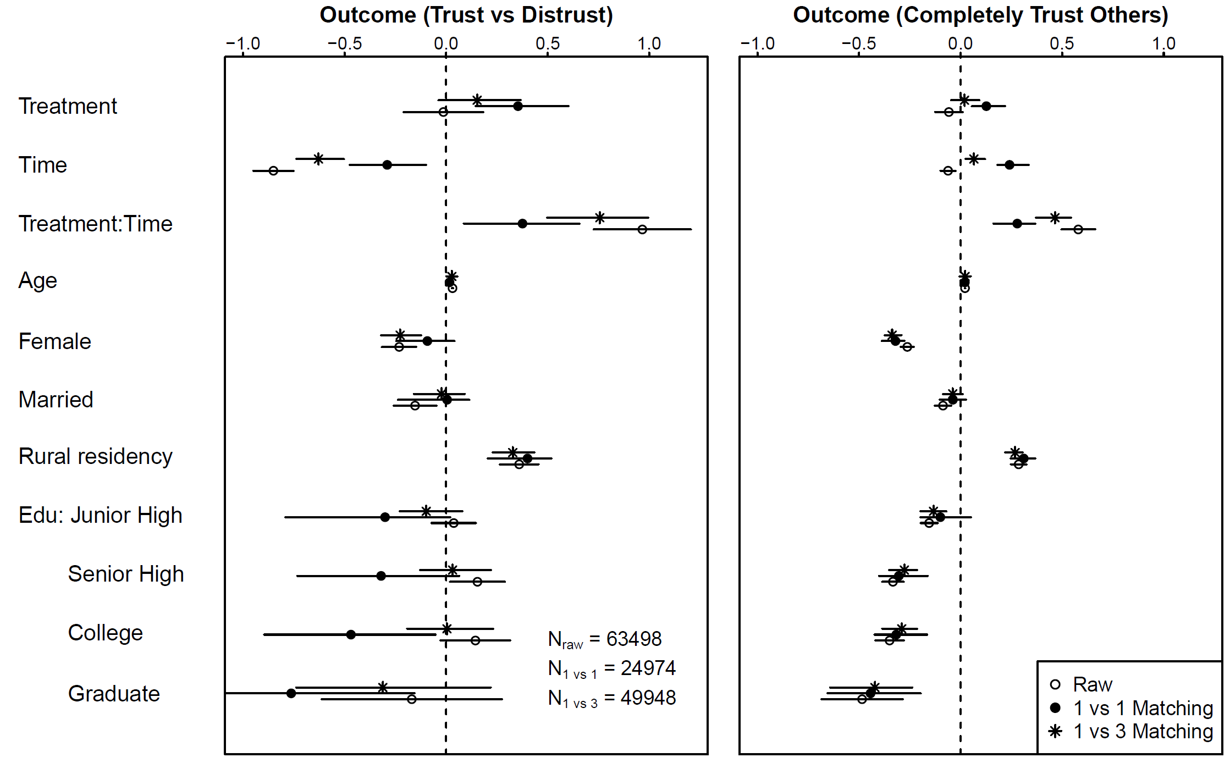

Figure 8: Regression Estimates of the DID Models. The outcome variables of trust versus distrust and completely trust versus other response categories are utilized in the left and right panels, respectively. The dots symbolize the regression coefficients of the DID models. The bars portray the 95% confidence intervals of these estimates. The confidence intervals for the 1 vs 1 and 1 vs 3 matchings are computed by determining the 95% quantile intervals from the estimates of the 24,000 iterations of the bootstrap procedures.

Given that the estimates and their significance from the logistic regression models in Figure 8 are not directly interpretable (Brambor 2006), we further illustrate these coefficients through assorted conditional plots in Figures 9 and Figure 10.

Figure 9 provides a visual representation of the Difference-in-Differences estimations by various treatment conditions before and after 2013 under fixed covariate settings (married females with college degrees and rural residency). The left panel portrays the time trend in the control group, indicating that, on average, after 2013, the probability of expressing trust in the central government was lower than before 2013. This suggests that, in the absence of treatment, individuals were less likely to express trust in the central government after 2013. The middle panel illustrates the difference between the treated and control groups before 2013, demonstrating that on average, those in the treatment group were more likely to express trust in the central government than those in the control group. This indicates that before 2013, when the tightened political control was not yet introduced, individuals in the treatment group on average trusted the central government more than those in the control group. The right panel shows that the difference in the probability of expressing trust in the central government for the treatment group before and after 2013 is not significant.

Taken together, the positive effect of the interaction term of treatment and time arises from the fact that if the fear induced by elevated political control dampened people’s trust in the central government after 2013, it did not have the same impact on regime insiders. Instead, as we argue in this paper, regime insiders turned fear into affinity and thus expressed trust in the central government, which in turn widened the gap that existed prior to 2013 between them and the regime outsiders.

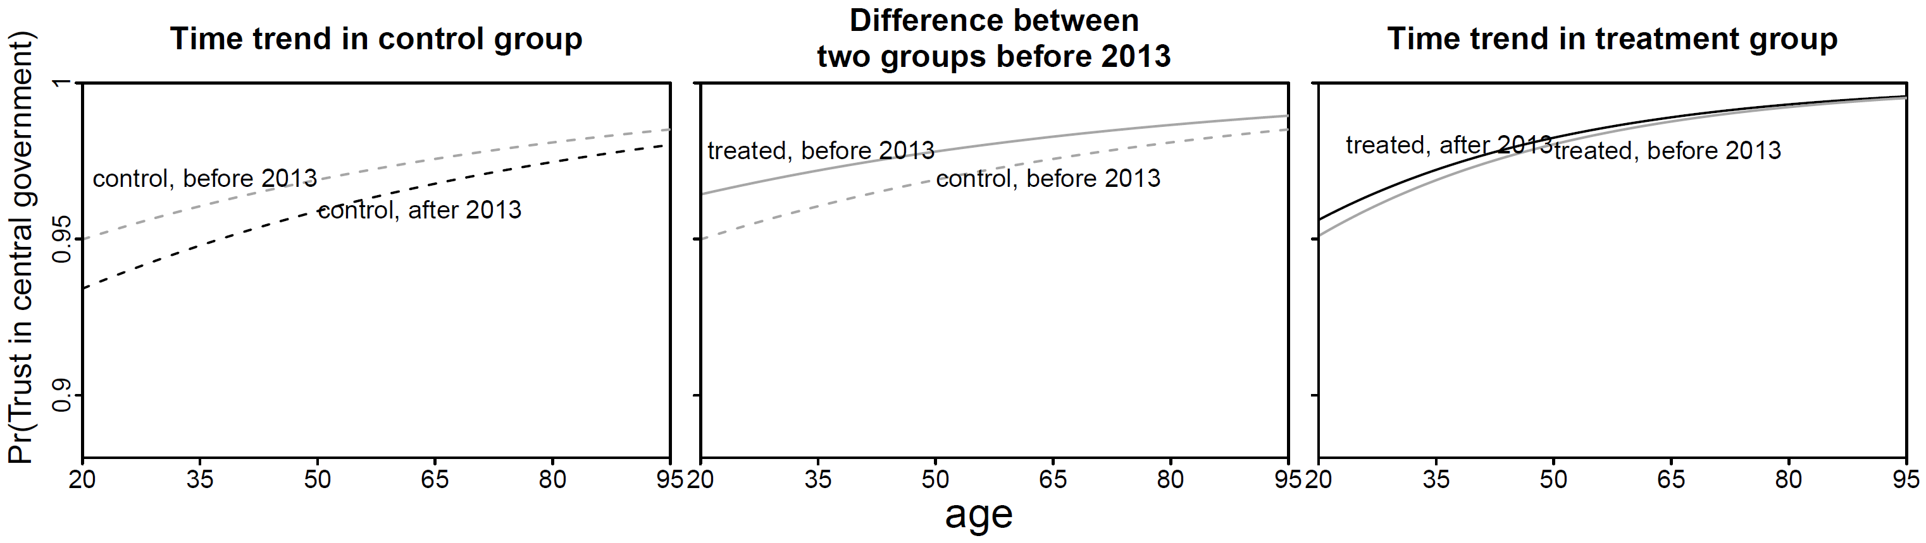

Figure 9: Visual display of DID estimations collapsed by various treatment conditions.

Figure 10 visually represents the magnitude of the effect among individuals with diverse personal traits. Briefly, this effect is more pronounced in individuals with higher education and those who do not hold rural residency. The effect does not seem to differ significantly between males and females, irrespective of their marital status. Furthermore, the strength of this effect appears to diminish with age. This visualization allows us to see how the influence of the treatment variable on trust in government varies across different segments of the population, shedding light on the heterogeneous impacts of increased political control.

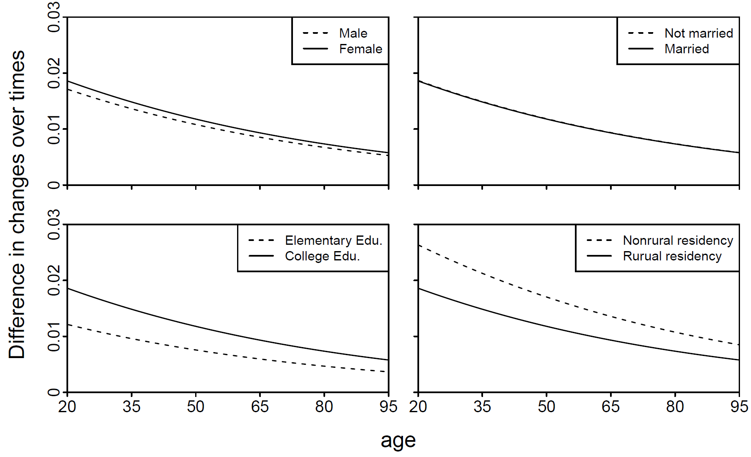

Figure 10: The conditional difference of the estimated DID effect across covariates.

While our primary model and robustness checks support our hypotheses, it is also possible that the fear-trust dynamics can be explained by a tendency to provide false responses in surveys, also known as "faking".[23] We address this possibility by conducting two widely used tests.

First, we compare the nonresponse rates of the treated group and the control group for the question of trust. The idea is to examine if the nonresponse rate in the treated group has increased more than that of the control group. Nonresponse rate is a widely accepted measure of self-censorship in surveys (Shi, 2008; Munro, 2018; Shen and Truex, 2021). The underlying assumption of this test is that if fear leads to falsification of opinions, some respondents may choose to "hide" by providing false answers, while others may opt to "hide" by not responding at all. If the nonresponse rate of the treated group does not deviate from that of the control group, it is reasonable to infer that pervasive "fake answers" are unlikely.

The second test focuses solely on the treated group, but contrasts their nonresponse rate on sensitive questions with that on less sensitive questions. The assumption is that if political fear within the treated group leads to faking, it would likely result in more faking on more sensitive questions. If the nonresponse rates on sensitive and less sensitive questions change in parallel or even in opposite directions, it is plausible that the observed increase in trust is reflective of genuine attitudinal change. In this case, we consider "trust in the central government" as the sensitive question and "trust in courts" as the less sensitive question, and compare their nonresponse rates.[24]

Figure 11 visually presents the results of both tests. In this figure, nonresponse encompasses various forms of question evasion, such as responses of "Do not know," "Do not understand," "Hard to say," or outright refusal to answer the question. The left panel reveals the nonresponse rate of the treated group has been consistently lower across all surveys, contradicting the faking hypothesis. Moreover, it has declined in tandem with the nonresponse rate of the control group since the treatment time, whereas the faking hypothesis would predict a rise. More importantly, the extent of its decline parallels that of the control group, suggesting that even if the treated group were faking, they were not faking more. Therefore, "faking" cannot account for the post-treatment divergence of political trust. The right panel conveys a similar message. Regardless of whether it's measured by cross-sectional comparison in a specific year or longitudinal trends, the sensitive question does not elicit a higher nonresponse rate. If anything, Figure 11 demonstrates that the treated group is, in fact, "faking" less.

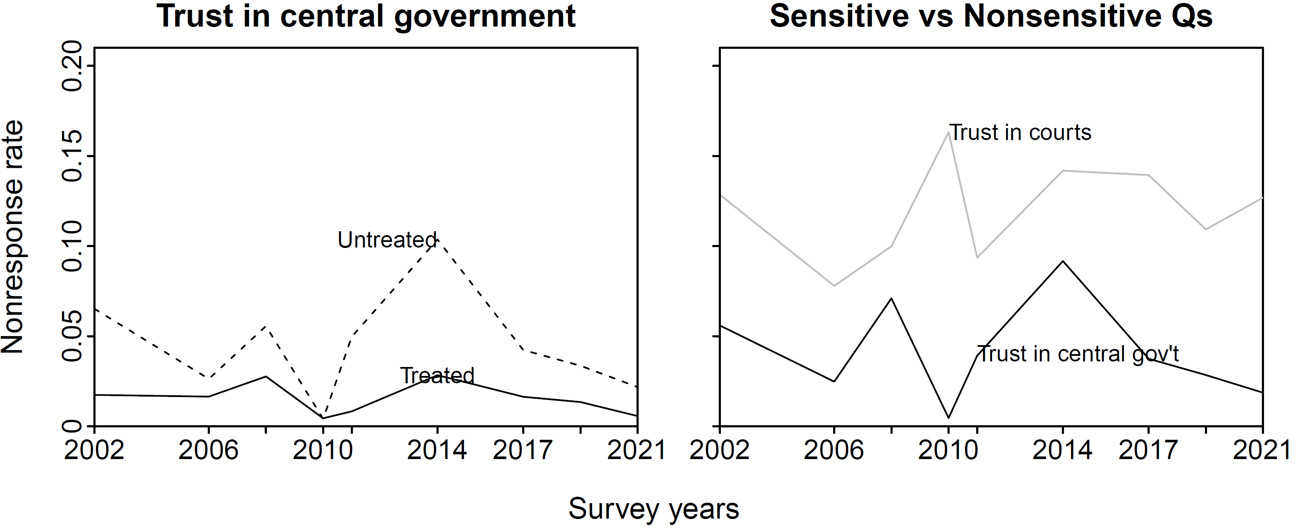

Figure 11: Comparing trends of nonresponse rates between treatment and control groups and between sensitive and nonsensitive questions. The comparison provides insight into the potential presence of faking or self-censorship in responses, which may impact the validity of the study's findings.

As shown in Figure 12, the PSM-DID analysis was re-run using an alternative measure of treatment. In this case, the new treatment measure identifies members of the CCP who have at least a college degree as the treated group, while the control group consists of individuals who do not meet this criterion. This alternative measure allows us to test whether the "more fear to more love" mechanism holds true under a similar treatment setting.

The focus of interest remains on the interaction terms between treatment and time. Figure 12 demonstrates that regardless of the two matching scenarios and the two outcome variables, the 95% confidence intervals of these coefficients do not include zero. This indicates that the effects of the alternative treatment measure are statistically significant. Therefore, our argument regarding the "more fear to more love" mechanism remains robust even with a different measurement of treatment.

This finding provides further support for our hypothesis and strengthens the validity of our results. It suggests that the observed effects are not driven by the specific measure of treatment used in the original analysis. Overall, this additional analysis reinforces the credibility of our research and enhances the confidence in the conclusions drawn from the study.

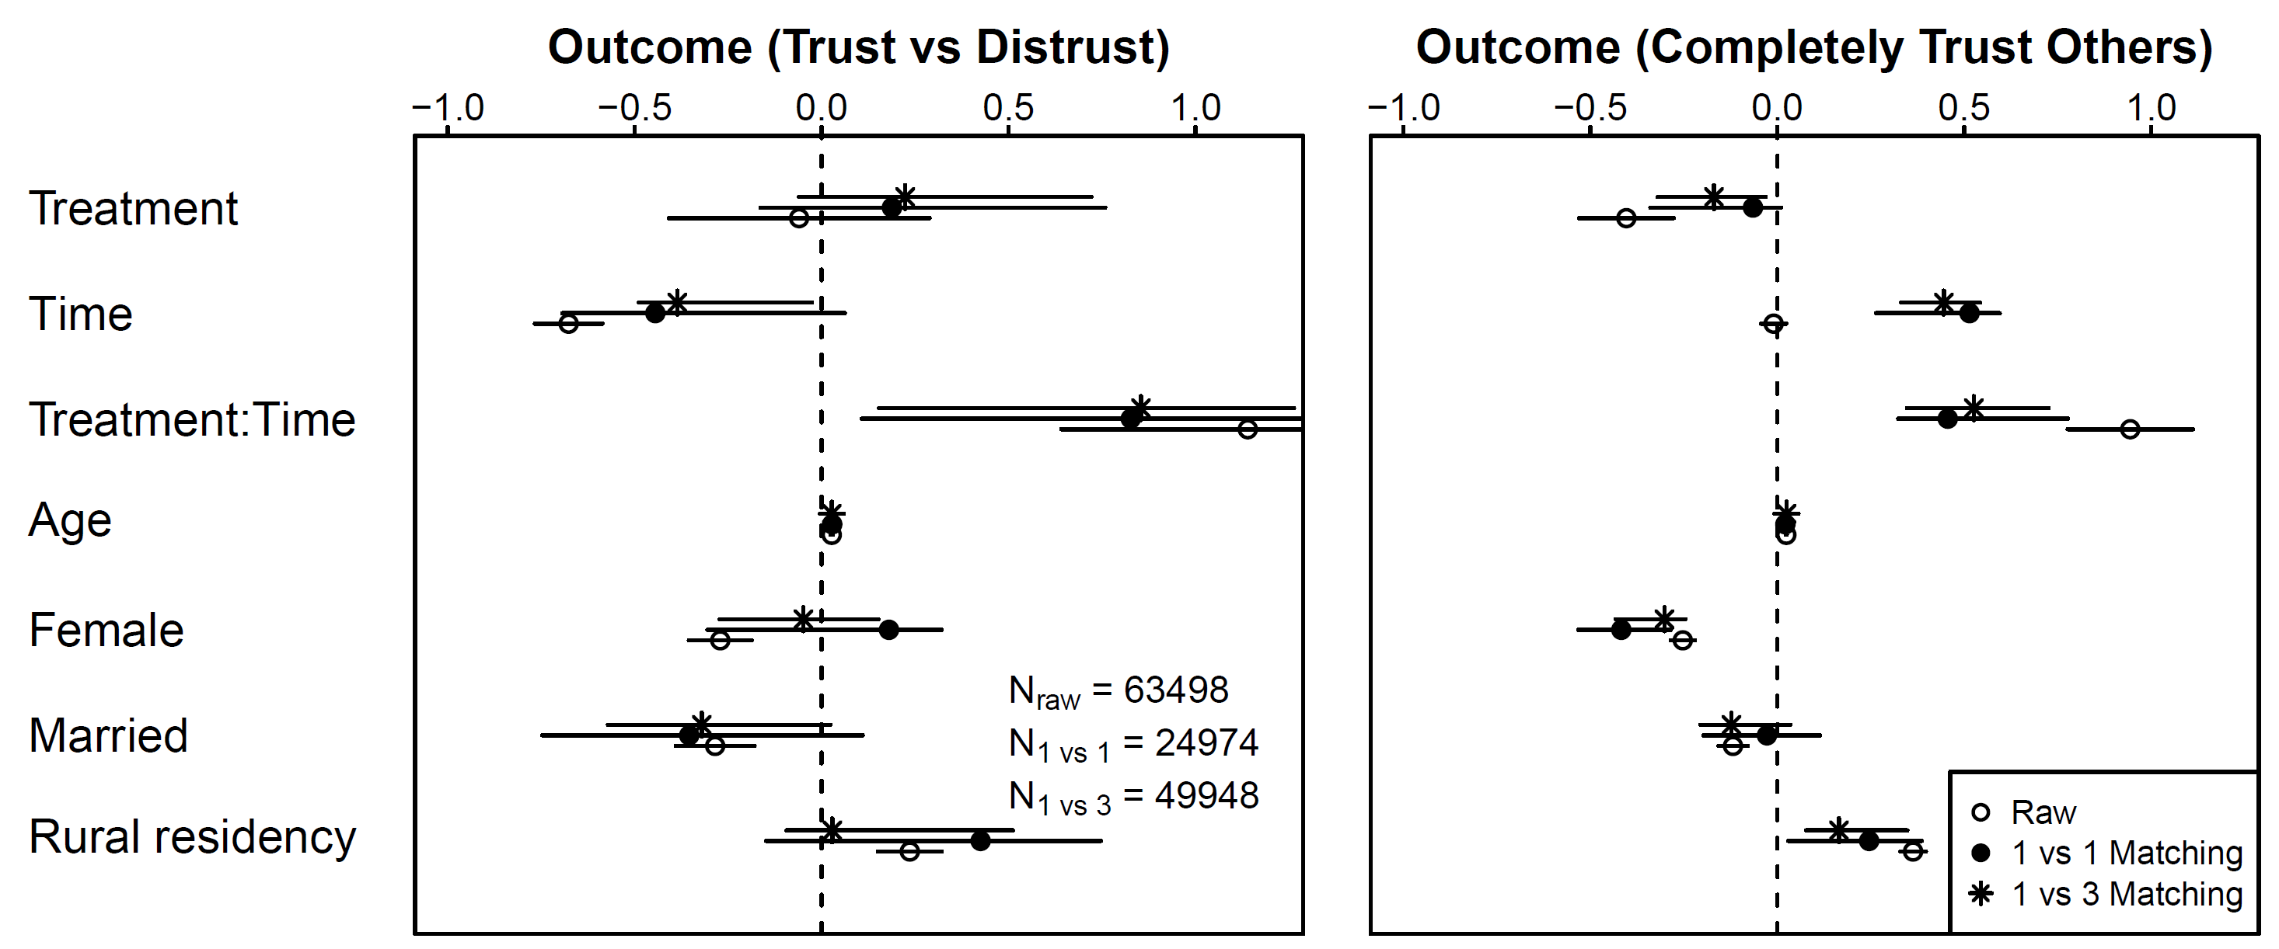

Figure 12: Regression estimates of the DID models using the alternative measure of treatment. In this analysis, the treatment indicator identifi those who are members of the CCP and possess at least a college degree. The outcome variables of trust versus distrust and completely trust versus other response categories are utilized in the left and right panels, respectively. The dots symbolize the regression coefficients of the DID models. The bars portray the 95% confidence intervals of these estimates. The confidence intervals for the 1 vs 1 and 1 vs 3 matchings are computed by determining the 95% quantile intervals from the estimates of the 24,000 iterations of the bootstrap procedures.

Lastly, we perform a placebo test to address potential pitfalls related to failing to control for additional covariates and potential omitted random factors that might alter the results. Figure 13 displays the 24,000 simulated PSM-DID results of this placebo test under two different matching scenarios, juxtaposed with the original estimates as illustrated in Figure 8. The distributions of these estimates for the fake treatment assignments are centered around 0, with standard deviations of 0.15 and 0.11 in the left and right panels, respectively. The reference lines of the original PSM-DID estimates are 0.38 and 0.77 under 1 vs 1 and 1 vs 3 matching, which are two standard deviations away from these distributions. Consequently, the randomly permuted treatments exhibit no effect on political trust in the central government. This reinforces the notion that our treatment effect on political trust is resistant to unobserved random factors.

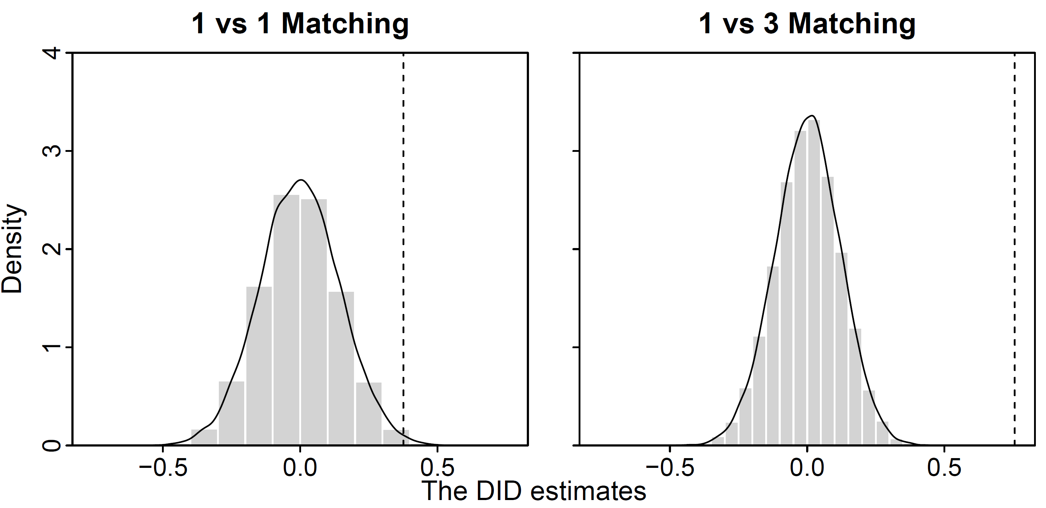

Figure 13: Distribution of Simulated DID Estimates from the Placebo Test. The dashed reference lines symbolize the estimates of the interaction terms of treatment and time, obtained from the DID regressions represented in Figure 8.

**Conclusion**

等主要结论确定后，我再根据results来写。下面只是一些additional remarks.

By acknowledging that political fear and trust can coexist and even reinforce one another, we can better understand the complex dynamics at play in the formation of political trust in China. It is essential to continue exploring the various factors that contribute to these contrasting findings and to develop a more nuanced understanding of political trust and wariness in the Chinese context. By doing so, we can develop a more comprehensive picture of the underlying mechanisms driving public opinion in authoritarian regimes, which could ultimately have significant implications for both domestic and international politics.

It should be noted that while our primary focus is on the changing level of political trust among "regime insiders" in the context of the anti-corruption campaign, the fear-love dynamics are not limited to this group in contemporary China. Political fear may be uneven among social groups and fluctuate at different times, but it is pervasive in an increasingly authoritarian regime. "Regime insiders" may fear the consequences of the anti-corruption campaign, but private businessmen worry about arbitrary policy changes; journalists fear making incorrect reports; lawyers worry about taking on the wrong cases; and social media bloggers fear losing their accounts for publishing one controversial article. We focus on "regime insiders" because their fear after the launch of the anti-corruption campaign is prominent and measurable, making our study more operationalizable.

This pervasive fear inevitably leads to more compliant behaviors through a tilting incentive structure. A director may be more inclined to make "patriotic" movies since creating a "wrong" movie could mean rejection by the censorship apparatus and the loss of millions in investors' money. A college student may be more likely to apply for Party membership because not doing so might limit their job prospects. A businessman might be more incentivized to invest in government-sponsored sectors due to the flow of subsidies. A social media blogger may be more likely to withhold their comments on the darker aspects of society for fear of being banned for political criticism.

According to the induced compliance paradigm of the cognitive dissonance theory, which we employ in this study, such behavioral compliance can lead to a genuine rise in regime endorsement through a process of self-persuasion. The high cost of non-compliant behaviors is a given in an increasingly tense atmosphere, but at the same time, no one forces a director to make a patriotic movie, a student to join the CCP, a businessman to invest in a government-sponsored sector, or a blogger to withdraw a post. Yet the surrounding incentive structure makes such choices "rational." Ultimately, human beings are programmed by evolution to be rational. However, it is precisely the "free choice" they exercise in fear that propels them into a psychological journey of transforming fear into love.

**Bibliography**

以下是补充的，请加到之前整理过的bib里，然后放进来。。

* Freedman and Fraser, “Compliance without pressure,” 1966;
* Steele, Claude, “The psychology of self-affirmation.” 1988
* Lydall, E. S., Gilmour, G., & Dwyer, D. M. (2010). Rats place greater value on rewards produced by high effort. Journal of Experimental Social Psychology, 46(6), 1134–1137.
* Van Veen/Krug，“Neural activity predicts attitude change in cognitive dissonance.” 2009.
* **Ang, “Autocracy with Chinese characteristics,” 2018**
* King, 2017. “[How the Chinese Government Fabricates Social Media Posts for Strategic Distraction, not Engaged Argument](https://gking.harvard.edu/50C).”
* Norris, Pippa. *Critical Citizens*. 1999
* Dalton and Wetzel, *Civic Culture Transformed*. 2014
* Shen, Xiaoxiao and Rory Truex. “In search of self-censorship.” British Journal of Political Science, 2021. 51.
* **Victor Shih, “Protective Umbrella,” 2018;**
* Minxin Pei, “How Not to Fight Corruption: Lessons from China,” Daedalus 147, No. 3 (2018): 219–20.

此外，文中有一些footnote实际上是新闻报道链接，请观察一下目标杂志是怎么处理这个问题的，然后依葫芦画瓢

**Online Appendix A: On the coding rules for the “regime insiders.”**

In this study, we identify the treated group, “regime insiders,” through the combination of CCP membership and job in state sector. The identification of the CCP membership is straightforward, requiring little explanation. The identification of state-sector jobs, however, is much less clear due to inconsistencies of surveys and vagueness of question wording. As explained in the paper, some surveys have the question on job nature, and some not. Even different rounds of the same survey can suffer such problems. This is why we had to combine different surveys to identify “regime insiders.”

To minimize the risk of comparing apples and oranges across different surveys, we enforce a unified rule in coding state vs. non-state sector across different surveys. The information we rely on to make the distinction is three-fold: the status of employment, nature of workunit and occupation codes. We adopt the following procedures to conduct the coding.

First, based on status of employment, we code all respondents unemployed, retired, laid off, peasants and housewives as 0 (non-state sector), retaining only those employed for further screening. The only exception are “students.” Although students are not officially employed, we still directly label them as 1 (state sector) because there is almost no private colleges and very few private high schools in China (the “students” in surveys are presumably college students or senior high-school students since all survey respondents are above 18). Although students do not depend on the state for salaries, they do depend on the state-owned schools for receiving diploma, financial aid, academic honors, job recommendation and in a sense, a bright future. We therefore label students as in state sector.

Second, based on occupation codes that provide information on whether the respondent is a physical laborer, we code all physical laborers as 0 no matter which type of workunit he/she reports. This is because of the theoretical question we intend to study: we want to detect the effect of political fear. As explained in the paper, there is no theoretical or empirical reason to believe pure physical laborers, such as cleaners working in government buildings, construction workers employed by state owned construction companies, or security guards for universities, are threatened either by any dimension of the anti-corruption campaign. So we only keep white-collar employees for further screening.

Third, among the white collar employees that remain, we use the “nature of workunit” question to identify state-sector employees. With only minor differences in question wording across surveys (see Appendix B), the answers to the question tend to have a very similar range. Taking the ABS 5 (2019) as an example, the question is phrased as “what is nature of your workunit or previous workunit before retirement?” A total of 13 categories are offered in the answer: 1) the CCP and government; 2) state-owned enterprises; 3) state-dominant joint venture or shareholding enterprises; 4) foreign capital dominant enterprises; 5) foreign owned enterprises; 6) government affiliated institutions (in Chinese, *shiye danwei*); 7) government affiliated institutions owned by joint venture of shareholding; 8) self-employed businessmen; 9) collective enterprises (including township owned enterprises); 10) private enterprises; 11) others; 98) do not know; 99) no answer. We group all CCP/government organizations, state owned/dominant or collective enterprises, and state-affiliated institutions (cateogory 1, 2, 3, 6, 7, 9 ) as tate sector, and the rest (category 4, 5, 8, 10, 11) as non state sector, leaving category 98 and 99 as they are. After these three steps, we reach a dummy variable that distinguishes state sector from non state sector. When a respondent is both a CCP member and a state sector employee, we code them as a “regime insider.”

**Online Appendix B: On the comparability of two key variables across different surveys.**

Due to frequent adjustment of questionnaires in different survey rounds, none of the major opinion surveys in contemporary China we are aware of consistently asks the same key questions we rely on to construct our IV and DV. We are therefore forced to combine three surveys to make longitudinal analyses possible. To be specific, we assemble the following surveys together in order to have reasonable intervals both before and after the treatment time: China Barometer Survey (CBS) 2002, Chinese Social Survey (CSS) 2006, Chinese General Social Survey (CGSS) 2010, CBS 2014, CSS 2017, CBS 2019 as well as CSS 2019, CSS 2021. Fortunately, two key questions we rely on, one on “nature of workunit” through which we identify our treated group (regime insiders), and the other on “trust in the central government” based on which we construct our DV, are framed in a highly similar way, thus making our approach justifiable.

Table 1 lists the questions on “nature of workunit” and their answers from all surveys we use. As seen from the table, both the questions and the answers are presented in a highly similar way. Although the concrete wording and the number/order of the answers can be slightly different, we minimize such differences by applying a unified rule in grouping answers, as explained in Appendix A. Considering that the variable is a dummy, thus the measurement being quite coarse, we believe the identification of “regime insiders” is consistent across all surveys.

Table 2 lists the questions on “trust in the central government” and their answers. Again, as seen from the table, both the questions and the answers are highly similar. Admittedly, some surveys offer 6 ordinal cateogories to choose from (CBS), some 5 (CGSS) and some 4 (CSS), which might affect the respondents’ choices. This is why one of our robust check confines the analyses to only one survey source, with an adjusted IV as explained in the paper. The results from this exercise is highly consistent with those from the combined surveys, thus increasing our confidence in the survey combination approach.

**Table 1. Wording of the “nature of workunit” questions and answers in different surveys.**

|  |  |  |
| --- | --- | --- |
| Survey | Question | Answers |
| CBS2002 | 101. What kind of workunit do you work in? | 0. Party and government organs  1. State affiliated institutions  2. State-owned enterprises  3. Collective enterprises  4. Private companies  5.Three types foreign-funded enterprises  6. Self-employed business  8. Others (please specify)  7. [Do not read] Not applicable  9. [Don’t read] Don’t answer |
| CBS2014 | SE3. What is the nature of your current/pre-retirement workunit? | 1. Party and government organs  2. State-owned enterprises  3. State-controlled joint venture, cooperative or joint-stock enterprises  4. Foreign-controlled joint venture, cooperative or joint-stock enterprises  5. Foreign-owned enterprises  6. State-affiliated institutions  7. State-affiliated joint venture or joint-stock institutions  8. Self employed business  9. Collective enterprises (including township enterprises)  10. Private companies  11. Other [specify]  98. [Don't read] I don't know  99. [Do not read] Do not answer |
| CBS2019 | SE5. What is the nature of your current/pre-retirement workunit? | 1. Party and government organs  2. State-owned enterprises  3. State-controlled joint venture, cooperative or joint-stock enterprises  4. Foreign-controlled joint venture, cooperative or joint-stock enterprises  5. Foreign-owned enterprises  6. State-affiliated institutions  7. State-affiliated joint venture or joint-stock institutions  8. Self employed business  9. Collective enterprises (including township enterprises)  10. Private companies  11. Other [specify]  98. [Don't read] I don't know  99. [Do not read] Do not answer |
| CGSS2010 | A59j. The type of workunit or company you are currently working for is: | 1. Party and government organs  2. Enterprises  3. State-affiliated enterprises  4. Social organizations  5. No workunit/self-employed/self-managing (joint venture)  6. Military  7. Others（specify） |
| A59k. The nature of ownership of the workunit or company you are currently working for is: | 1. State-owned or state-controlled  2. Collective owned or collective-controlled  3. Private owned /private managed /private-controlled  4. Hong Kong, Macao and Taiwan funded or controlled  5. Foreign-owned or foreign-controlled  6. Others (please specify) |
| CSS2006 | B4a. The type of workunit/company you work for is: | 1. Party and government organs  2. State-owned enterprises  3. State-affiliated institutions  4. Collective enterprises/institutions  5. Non-state (private) enterprises/institutions  6.Three types foreign-funded enterprises/institutions  7. Self-managing business  8. Rural family business  9. Rural collective economy  10. Social groups and community self-governing organizations  11. Others (please specify)  12. No workunit  13. Not sure |
| CSS2017 | B4a. The worunit/company where you do this non-agricultural job is: | 1. Party and government organs, people's organizations, and the military  2. State-owned enterprises and state-controlled enterprises  3. State-affiliated/collective institutions  4. Collective enterprises  5. Private companies  6.Three types foreign-funded enterprises/institutions  7. Self-employed business  8. Collective-owned institutions (collective non-enterprise workunits)  9. Self-governing organizations such as village committees and neighborhood committees.  10. Others (Specify)  11. No workunit  98. Not Sure |
| CSS2019 | B4a. The worunit/company where you do this non-agricultural job is: | 1. Party and government organs, people's organizations, and the military  2. State-owned enterprises and state-controlled enterprises  3. State-affiliated/collective institutions  4. Collective enterprises  5. Private companies  6.Three types foreign-funded enterprises/institutions  7. Self-employed business  8. Collective-owned institutions (collective non-enterprise workunits)  9. Self-governing organizations such as village committees and neighborhood committees  10. Social groups and self-governing organizations  11. Others (please specify)  12. No workunit  98. Not sure |
| CSS2021 | B5a:The worunit/company where you do this non-agricultural job is: | 1. Party and government organs, people's organizations, and the military  2. State-owned enterprises and state-controlled enterprises  3. State-affiliated/collective institutions  4. Collective enterprises  5. Private companies  6.Three types foreign-funded enterprises/institutions  7. Self-employed business  8. Collective-owned institutions (collective non-enterprise workunits)  9. Self-governing organizations such as village committees and neighborhood committees  10. Social groups and self-governing organizations  11. Others (please specify)  12. No workunit  -1. Not sure |

**Table 2. Wording of the “trust in the central government” question and answers in different surveys.**

|  |  |  |
| --- | --- | --- |
| Survey | Question | Answers |
| CBS2002 | 73. If we use 1 to represent complete distrust, and 6 to represent complete trust, how do you trust the central government? | 1、Completely distrust  2、Fairly distrust  3、Somewhat distrust  4、Somewhat trust  5、Fairly trust  6、Completely trust  0、Hard to say  8、Do not know  9、No response |
| CBS2014 | E1.How much do you trust the central government? | 1、Completely distrust  2、Fairly distrust  3、Somewhat distrust  4、Somewhat trust  5、Fairly trust  6、Completely trust  7、Do not understand  8、Do not know  9、No response |
| CBS2019 | E4. How much do you trust the central government? | 1、Completely distrust  2、Fairly distrust  3、Somewhat distrust  4、Somewhat trust  5、Fairly trust  6、Completely trust  7、Do not understand  8、Do not know  9、No response |
| CGSS2010 | D3. How much do you trust the central government? | 1、Completely distrust  2、Fairly distrust  3、Between trust and distrust  4、Fairly trust  5、Completely trust |
| CSS2006 | E5. In general, how much do you trust the central government? | 1、Distrust very much  2、Fairly distrust  3、Fairly trust  4、Trust very much  5、Not sure. |
| CSS2017 | F1a2: Could you please tell us: do you trust the central government? (choose one) | 1. Complete distrust  2. Fairly distrust  3. Fairly trust  4. Trust very much  8. Hard to say |
| CSS2019 | F1a. Could you please tell us: do you trust the central government? (choose one) | 1. Complete distrust  2. Fairly distrust  3. Fairly trust  4. Trust very much  8. Hard to say |
| CSS2021 | F1a. Could you please tell us: do you trust the central government? (choose one) | 1. Complete distrust  2. Fairly distrust  3. Fairly trust  4. Trust very much  -1. Hard to say |

Online Appendix C.

朱萌，请在此解释Figure 1 中所有数据的信息来源，用列表的方式亦可，加一小段文字说明（英文）

The following news reports summarise the results of China's anti-corruption campaign from 2006 to 2022, including the number of cases filed and the number of people disciplined by the Party each year.These authoritative or official reports help us understand the anti-corruption campaign in China before and after Xi come to power.

|  |  |  |
| --- | --- | --- |
| Report time | Headlines | Source |
| Apr 1,  2006 | Deepening the Party's integrity and anti-corruption struggle | <http://www.gov.cn/node_11140/2006-04/01/content_242262.htm> |
| February 14, 2007 | Expanding the work field to prevent and control corruption from the source | <http://www.ce.cn/xwzx/gnsz/szyw/200702/14/t20070214_10431426.shtml> |
| February 23, 2009 | Focusing on the improving system of punishment and prevention of corruption | <http://mil.news.sina.com.cn/2009-02-23/0716543101.html> |
| February 21, 2011 | Striving to achieve new results in the construction of the Party's integrity and the fight against corruption | <https://sthjt.qinghai.gov.cn/hjgl/qmcyzd/zhxx/201102/t20110221_64234.html> |
| January 9, 2013 | The Central Commission for Discipline Inspection (CCDI) informs investigated cases in 2012 | <https://news.12371.cn/2013/01/09/ARTI1357705901155210.shtml> |
| January 10, 2014 | Central Commission for Discipline Inspection (CCDI) informs the construction of the Party's integrity and anti-corruption efforts in 2013 | <https://www.ccdi.gov.cn/special/schy/ttgz_schy/201401/t20140113_16913.html> |
| January 29, 2015 | Report on the Work of the Fifth Plenary Session of the 18th Central Commission for Discipline Inspection | <https://www.ccdi.gov.cn/special/wcqh/tt/201501/t20150130_50819.html> |
| January 25, 2016 | Report on the Work of the Sixth Plenary Session of the 18th Central Commission for Discipline Inspection | <http://cpc.people.com.cn/n1/2016/0125/c64094-28080355.html> |
| January 6, 2017 | Report on the Work of the Seventh Plenary Session of the 18th Central Commission for Discipline Inspection | <https://zgjjjc.ccdi.gov.cn/bqml/bqxx/201701/t20170121_93114.html> |
| January 11, 2018 | Central Commission for Discipline Inspection informs national supervision and investigation cases in 2017 | <https://www.ccdi.gov.cn/toutiao/201801/t20180110_161529.html> |
| January 9, 2019 | Central Commission for Discipline Inspection informs national supervision and investigation cases in 2018 | <https://www.ccdi.gov.cn/toutiaon/201901/t20190108_94551.html> |
| January 18, 2020 | Central Commission for Discipline Inspection informs national supervision and investigation cases in 2019 | <https://www.ccdi.gov.cn/toutiaon/201901/t20190108_94551.html> |
| January 26, 2021 | Central Commission for Discipline Inspection informs national supervision and investigation cases in 2020 | <https://www.ccdi.gov.cn/yaowenn/202101/t20210126_84660.html> |
| January 21, 2022 | Central Commission for Discipline Inspection informs national supervision and investigation cases in 2021 | <https://www.ccdi.gov.cn/toutiaon/202201/t20220121_166060.html> |
| January 13, 2023 | Central Commission for Discipline Inspection informs national supervision and investigation cases in 2022 | <https://www.ccdi.gov.cn/toutun/202301/t20230113_241621.html> |

1. What makes this experiment particularly intriguing is that people who were offered a smaller amount of money experienced an even greater attitude change. This is likely due to the fact that the cognitive dissonance aroused in the low-reward condition is even greater.
2. Indeed, while the two interpretations of cognitive dissonance theory may differ, they are not necessarily contradictory, and both have contributed to our understanding of the theory. Therefore, we choose to adhere to the general label "cognitive dissonance theory" to avoid delving too deeply into social psychology debates and instead focus on its implications for our research question.
3. In China, the state maintains a firm grip on certain pivotal industries, such as railroads, airlines, finance, and oil. Furthermore, it is worth noting that all land, from a legal perspective, is either state-owned or collectively owned.
4. Tianlei Huang, and Nicholas R. Lardy. 2023. China’s support for the private sector is only lip service so far. <https://www.piie.com/blogs/realtime-economics/chinas-support-private-sector-only-lip-service-so-far>. Accessed on April 30, 2023.
5. Xinhua. 2019. Authorized Release: CPC Constitution. http://www.xinhuanet.com/politics/19cpcnc/2017-10/28/c_1121870794.htm. Accessed on April 30, 2023.
6. It is possible that active participants may have been firm believers from the outset, but their active involvement could further reinforce their convictions.
7. Xinhua. 2021. Authorized Release) Statistical Bulletin of the Communist Party of China. <http://www.xinhuanet.com/politics/2021-06/30/c_1127611673.htm>. Accessed on April 30, 2023.
8. This number excludes the military and state-owned enterprises.
9. # Civil Service Examination Website. 2023. Analysis of the Number of National Civil Servants in Previous Years. <https://m.gwy.com/gjgwy/232188.html>. Accessed on April 30, 2023.

  
10.
11. Edward White, and Victor Mallet. 2022 (February 22). How Xi Jinping’s anti-corruption crusade went global. <https://www.ft.com/content/ae4d37bd-0440-491b-a4b7-25ab6158e6ad>. Accessed on April 30, 2023.
12. According to the annual reports published by the CCDI, the number of investigations conducted is comparable to the number of punishments imposed. For instance, in 2020, there were 618,000 investigations and 604,000 punishments.
13. The numbers were reported by Pei Xiao, deputy Party secretary of the Central Commission of Discipline Inspection during the 20th Party Congress. See: 《中国经济周刊》22.10.17 现场报道.

    <https://baijiahao.baidu.com/s?id=1746930636390613166&wfr=spider&for=pc>
14. 举例。。。
15. Exact sources of the numbers in Figure 1 can be found in Appendix C.
16. Oftentimes, increased anti-corruption measures coincide with a decrease in material incentives, requiring greater effort for individuals to achieve comparable rewards. In accordance with the fundamental principles of the induced compliance paradigm, situations characterized by high effort and low reward engender cognitive dissonance, which consequently leads to a more pronounced shift in attitudes.
17. 解释，江、胡时代也有。。。
18. To illustrate, in the year 2002, only 41 respondents selected the "distrust" response (compared to 2,964 respondents who chose the "trust" response). Similarly, for the years 2006 and 2014, there were less than 200 cases of distrustful responses (compared to over 6,600 and 3,500 cases of trustful responses, respectively). Furthermore, the matching process and missing values in control variables may further decrease the number of cases available for analysis, potentially compromising the reliability of our regression results.
19. The term "work unit" (*gongzuo danwei*) typically denotes the organization or institution where an individual is employed, such as a corporation, government bureau, educational institution, or medical facility. In China, one's work unit often carries significant weight in their social identity and status, as it can be linked to a specific level of prestige, compensation, and perks. Moreover, numerous aspects of an individual's daily routine, such as housing, healthcare, and social events, may be intimately connected to their work units.
20. It is important to note that different surveys, or even different rounds of the same survey, may frame questions and their answers in slightly varying ways. Here we use the questionnaire of the ABS (wave 5) as an example.
21. The surveys record respondents’ concrete occupations through a system of occupation codes, through which we are able to determine whether this respondent is a physical labor or not.
22. 709律师。。。
23. 其实未必矛盾
24. Given the scarcity of consistent questions across all surveys, our options for comparison are rather limited. Even queries regarding "trust in local governments" are often framed inconsistently, with some surveys asking about "trust in local governments," others about "trust in county/district government," and some about "trust in township-level government." In this context, we chose to compare "trust in the central government" (as the sensitive question) with "trust in courts" (as the less sensitive question). The rationale behind this selection is that in China's political context, "trust in courts" is considered less sensitive because the judiciary is often perceived as less politically charged compared to the central government. Furthermore, trust in courts is generally assumed to be more related to personal experiences (e.g., legal disputes), and therefore less influenced by political control or fear. By comparing the nonresponse rates to these two questions, we aim to discern whether potential faking is prevalent among responses to politically sensitive questions, and whether such behavior is attributable to the treatment.